Summary of the machine learning methodology

In this work, we employed a sequential machine learning approach based on Bayesian optimization (BO) to optimize the power conversion efficiency (PCE) of perovskite thin-film photovoltaic devices by varying the process conditions. In BO for process optimization, one attempts to find the specific process condition, $x_{i}$, for which the black-box objective function, $f(x)$, mapping the condition search space (A), to the target property (PCE), is maximal,¹

$$x_{i}= \underset{x∈A}{argmax}{f(x)}$$ | (1)

Such a BO campaign typically starts by selecting an initial sample of process conditions, after which the output property of interest is determined for each of those. Subsequently, a surrogate model for the true objective function $\hat{f}(x)$ – the prior – is trained based on the observations made, and an acquisition function is constructed, which calculates the utility of performing an additional measurement, i.e., evaluating the objective function, at the point x. Utility may be measured in a number of ways: the predicted PCE value, the amount of information this new point will provide the surrogate model, the likelihood this point will improve upon the current maximum, etc.² Once new condition combinations have been acquired, the surrogate model is updated – resulting in the posterior – and acquisition can be repeated. This updating process can be performed in an iterative manner until significant improvements in PCE values are no longer observed from batch to batch.
As a preliminary step in this work, a tentative search space of process conditions for PCE optimization was defined based on expert considerations, with a particular aim to balance experimental feasibility and broadness of the search/parameter space (cf. Table 1). In total, 1.3 billion distinct combinations of process parameters can be distinguished within this space.

Process variable | Total range (interval)
Volume NMP (ml) | 0 – 100 (5)
Volume DMF (ml) | 0 – 100 (5)
Volume DMSO (ml) | 0 – 100 (5)
Perovskite concentration (M) | 0.8 – 1.8 (0.1)
Annealing temperature (°C) | 100 – 160 (5)
Vacuum pressure (Pa) | 20 – 400 (10)
Vacuum pressure time (s) | 0 – 55 (2)

Table 1: An overview of the search space considered in this work.

As an initial test to ensure the appropriateness of the selected search space, an exploratory sample of 45 process conditions were selected, and PCE values were determined crudely, i.e., a single device was synthesized – and its efficiency measured – for each condition. Significant variations in the measured PCE could be observed across this sample (from 5.6% up to 21.9%), providing confidence that the selected process variables will indeed enable extensive modulation of the efficiency. Consequently, the selected set of process conditions was retained for the actual optimization campaign.
With the search space defined and validated, the BO campaign was initiated. We decided to sample 20 points from the search space simultaneously, because the most time-consuming step of the experimental setup, i.e., the thermal evaporation, can accommodate up to 20 substrates per batch. As such, this specific batch size can be expected to be the most cost-effective, as it balances the time cost per individual measurement and the feedback/update frequency of the regression model. To enable…
The initial sampling of the search space was performed manually, informed by the results from the preliminary screening, and with the aim of covering the ranges of the individual process variables to a reasonable extent, as well as trying to limit the number of solvents added to the precursor (by sampling particularly the regions of the parameter space where 0 ml of either the NMP, DMF or DMSO solvent is used; cf. Fig. 1 for a visual overview of the coverage for every process variable).
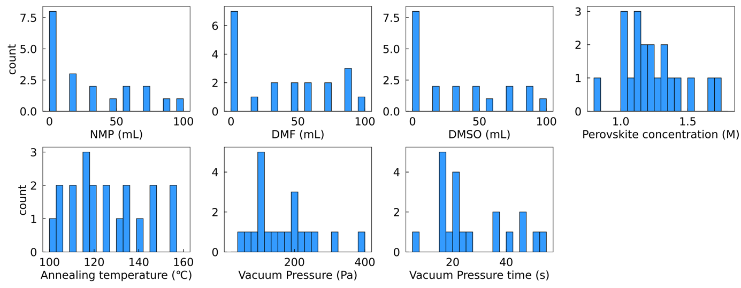
Figure 1: Bar plots visualizing the distribution of the initial sample across the search space for each of the process variables.

During the optimization campaign, we aimed to increase the accuracy and robustness of the registered efficiencies for sampled points – compared to the exploratory sample – by mitigating the influence of the noise inherently associated with individual experimental PCE determinations. As such, four devices were prepared for every combination of process parameters sampled, and only the mean efficiency was registered. To save time and not waste resources, if defects were visually detected on the first thin film prepared for a specific process condition, then the device was discarded immediately and no further attempts to synthesize devices were made for this point in the search space.
For the construction of the main surrogate model, Gaussian Process regression with a matern52 kernel was selected.³ Matern52 is a flexible kernel, enabling it to treat potential discontinuities in the data better. Additionally, the kernel was selected in its anisotropic form, so that each of the kernel parameters could be tuned independently for every input variable, facilitating the assignment of a stronger impact/relevance on the predicted output variable, i.e., the measured efficiency, by some variables compared to others. It should be noted that the surrogate model, evaluated at point x, yields both a mean prediction for that point, $\hat{f}(x)$, as well as a standard deviation $σ(x)$, which quantifies the uncertainty of the model about its prediction at this point.
To inform the selection of process condition combinations to acquire in subsequent BO batches, a compounded acquisition function was selected. The utility function of upper confidence bound (UCB) was selected as the basis,⁴

$${acq}_{UCB}(x;β)= \hat{f}(x) + β*σ(x)$$ | (2)

where $β$ is the parameter that adjusts the relative weight of prediction uncertainty $σ(x)$ over the prediction mean value $\hat{f}(x)$. In general terms of balancing exploration and exploitation, higher $β$ values leads to more exploration, while lower $β$ values lead to more exploitation. In this work, we set $β$ equal to 1, in line with previous work.⁵
While it was our goal to focus primarily on the (accurate) efficiencies measured as part of the BO campaign, we also did not want to lose the information from the preliminary sample and the visual defects data altogether during acquisition. As such, two probabilistic constraints were defined, in line with previous work by Buonassisi and co-workers.⁶ The first of those probabilistic constraints, ${Pr[C}_{1}(x)]$, corresponds to the probability that the thin film will be produced without visual defects. This film constraint is defined based on a latent constraint function $g_{constr,1}(x)$,⁷

$${Pr[C}_{1}(x)]=Pr[g_{constr,1}\left(x\right)≥ 0)]$$ | (3)

where $g_{constr,1}\left(x\right)$ is a secondary surrogate model in its own right, which is constructed with the help of Gaussian Processes as well, based on the process conditions evaluated so far. In the training data of this Gaussian process model, $\left\{(x_{i};y_{i})\right\}$, $y_{i}$ is assigned the value +0.5 if the fabricated device did not have visually detectable defects, and -0.5 if the device did contain such defects. As a result of this convention, Eq. 3 evaluates to 0 for all training points which yielded devices with visual defects, and to 1 for all training points resulting in devices without defects. For all other points in the search space, a probability – to have a device without defects – is interpolated based on the constructed surrogate model.
The second probabilistic constraint, ${Pr[C}_{2}(x)]$, has been defined with the aim of penalizing regions of the search space around points, evaluated during preliminary sampling, which yielded subpar PCE values. This constraint is defined based on a latent constraint function $g_{constr,2}(x)$,⁷

$${Pr[C}_{2}(x)]=Pr[g_{constr,2}\left(x\right)≥ 0)]$$ | (4)

where $g_{constr,2}\left(x\right)$ is another secondary surrogate model, which has again been constructed with the help of Gaussian Processes. The training points $\left\{(x_{i};y_{i})\right\}$ for $g_{constr,2}\left(x\right)$ are derived from the process conditions and corresponding PCE values for all the points in the preliminary sample, but then with the PCE values rescaled as follows,

$$\left\{(x_{i};y_{i})\right\} →\left\{(x_{i};y_{i}-mean(\left\{y_{i}\right\}))\right\}$$ | (5)

where $mean(\left\{y_{i}\right\})$ is the mean of all the PCE values encountered in the preliminary sample. Based on these definitions, it can indeed be inferred that Eq. 4 will evaluate to 0 for all points in the preliminary sample that yielded a PCE below average, whereas it will evaluate to 1 for points that yielded a PCE above average during preliminary sampling. For all other points in the search space, a probability to yield an above average PCE is interpolated based on the constructed surrogate model.
The two constraints were then combined with ${acq}_{UCB}$ to yield the final acquisition function as follows,

$${acq}_{full}(x)= {acq}_{UCB}(x)*{(0.5+0.5*Pr⁡[C}_{1}(x)])*{(0.8+0.2*Pr[C}_{2}(x)])$$ | (6)

Note that the individual constraints have been softened, i.e., rescaled, in Eq. 6, to make the acquisition process more conservative with respect to the film and preliminary screening data. The weighting factors introduced to this end were chosen to make the current data 5 times more important than the preliminary screening data, and the qualitative film quality information is considered half as important as the information of the actual efficiency measurements. By introducing these constraints in the acquisition function, one can expect to sample fewer points in the region where film quality is poor, or where low device efficiency was obtained in the preliminary experiments, throughout the BO campaign.
As a final note, it should be mentioned that, since the purpose of the probabilistic constraints is mainly to guide the model away from regions in the search space with a low probability of success, radial basis function kernels were used to model surrogates $g_{constr,1}\left(x\right)$ and $g_{constr,2}\left(x\right)$. Radial basis functions are less flexible than matern52 kernels, and consequently, their smoother/more rigid behavior intuitively feels more appropriate to crudely define unfavorable regions of the search space.
Surrogate models and acquisition functions were implemented, based on previous work by Buonassisi and co-workers,⁶ with the help of Emukit⁸ and GPy.⁹ All the code associated with this project has been made available through a GitHub repository [ADD LINK HERE]. Below, analyses for each of the batches are presented.

Analysis of the initial batch & selection of the first batch
A first observation to be made about the initial sample is that, as expected, individual measurements for a specific process condition tend to be noisy, particularly towards lower PCE values: on average, the spread between the best and worst PCE measured amounts to 3.2% in this sample. As indicated above, by taking the average PCE for four distinct devices for each condition, one can expect to mitigate this noise somewhat. The best mean PCE value obtained across the initial batch already amounts to 20.1%; the best individual measurement altogether corresponds to a PCE of 21%.
In Figure 2, an overview of the first batch of experimental conditions, selected with the help of the BO algorithm based on the initial batch, is provided. From these plots, it is clear that for some variables, the model already selects in a fairly aggressive manner a specific part of the search space to explore (cf. vacuum pressure and the various solvents), whereas it remains less committed to a specific region for some of the other variables (cf. perovskite concentration, annealing temperature and vacuum pressure time in particular).

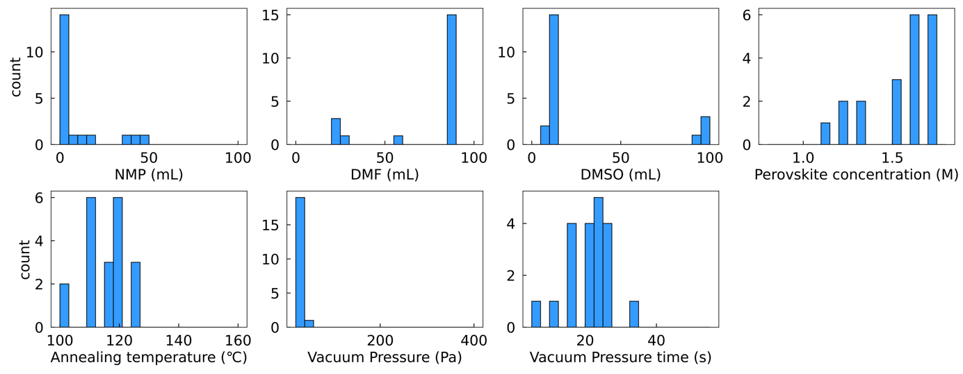
Figure 2: Bar plots visualizing the distribution of the first batch of experiments, selected by the BO algorithm, across the search space for each of the process variables.

In Figure 3, an overview of the first round of acquisition is provided. On the left, the PCEs – as well as the associated uncertainties – predicted by the surrogate model for the training points, as well as the points acquired in this acquisition round, are shown. On the right, the acquisition probabilities for each sampled point are visualized. In dark blue, the raw acquisition values, as evaluated through Eq. 2, are shown. In red, the multiplication factor introduced by the two probabilistic constraints is visualized (cf. Eq. 6). Finally, in light blue, the product of both quantities is shown.
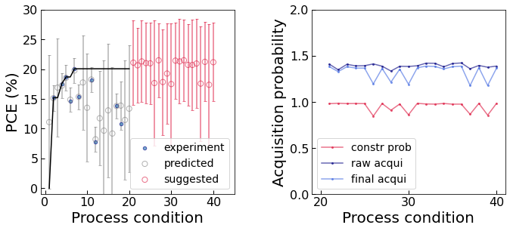
Figure 3: The acquisition process for the first sampling round. Plot of the predicted – and measured – PCE values for both the initial batch and the first selection of acquired points; the best PCE value measured so far is denoted by the bold black curve (left). Graphical summary of the acquisition probabilities across this first selection (right).

Finally, we aimed to visualize the behavior of the surrogate objective function across the search space. Due to the multidimensionality of the process variable space, we are limited here to constructing contour plots, where only two variables are considered at once. In practice, a contour plot of the surrogate function for two variables a and b is produced in our approach by sampling 1000 random points from the search space, after which the values for the two variables are systematically varied across a grid and the surrogate function is called every time the parameters are changed. For each point (a,b) across the 2D-intersection of the search space, a representative sample of 1000 (surrogate) objective values is obtained in this manner. By selecting respectively, the minimum, maximum and mean value of these samples at every point, contour plots can then finally be constructed.
The methodology described above has been applied to every pair of process variables; in Figure 4, a representative sample of the resulting plots is shown.
Figure 4: Sample of the 2D contour plots for the surrogate objective function: (a) DMF vs. NMP volumes, (b) Perovskite concentration vs. DMF volume. Maximum (left), mean (middle) and minimum (right) surrogate objective function values across the sample of process conditions at every grid point are visualized.

Analysis of the first batch & selection of the second batch
A remarkable result is that already in the first batch, the algorithm steers clear from process conditions that give rise to devices with visually detectable defects: all of the thin films were successfully produced in this batch. Furthermore, a steady improvement in the optimal PCE values is observed. After this first batch, the best mean PCE value obtained amounts to 22.4%; the best individual measurement altogether corresponds to a PCE of 23.2%
In Figure 5, an overview of the second batch of experimental conditions, selected with the help of the BO algorithm based on the data so far, is provided. From this figure, it is evident that even for the variables for which a wide range of values were still sampled in the first round, the algorithm now starts to sample in an increasingly narrow manner. This is a reflection of the fact that as more data becomes available, the algorithm becomes increasingly confident about the region of the search space that leads to high PCE values.

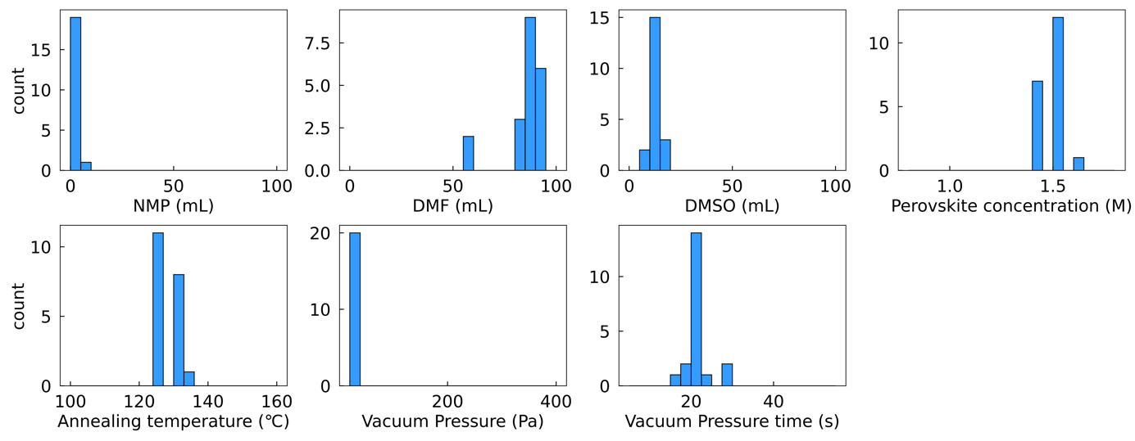
Figure 5: Bar plots visualizing the distribution of the second batch of experiments, selected by the BO algorithm, across the search space for each of the process variables.

In Figure 6, an overview of the second round of acquisition is provided, following the same conventions as in Figure 3. Note that the uncertainty of the predictions for the points acquired in this round are much smaller than in the previous one.
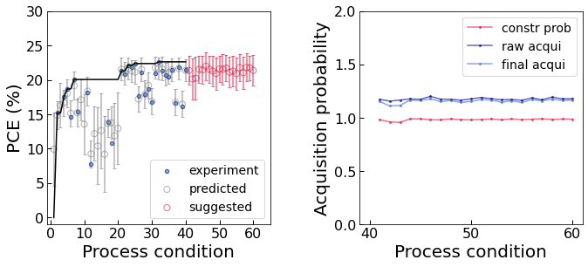
Figure 6: The acquisition process for the second sampling round. Plot of the predicted – and measured – PCE values for both the initial batch and the first selection of acquired points; the best PCE value measured so far is denoted by the bold black curve (left). Graphical summary of the acquisition probabilities across this second selection (right).

In Figure 7, similar contour plots as for round 1 are shown. Note that the contour plots have not changed substantially compared to those from the previous round; only in the margins one can observe subtle changes.
Figure 7: Sample of the 2D contour plots for the surrogate objective function: (a) DMF vs. NMP volumes, (b) Perovskite concentration vs. DMF volume. Maximum (left), mean (middle) and minimum (right) surrogate objective function values across the sample of process conditions at every grid point are visualized.

Analysis of the second batch & selection of the third batch
After the second batch, the best mean PCE value obtained his risen further to to 24.7%; the best individual measurement now corresponds to a PCE of 24.9%. In Figure 8, an overview of the third batch of experimental conditions, selected with the help of the BO algorithm based on the data so far, is provided.

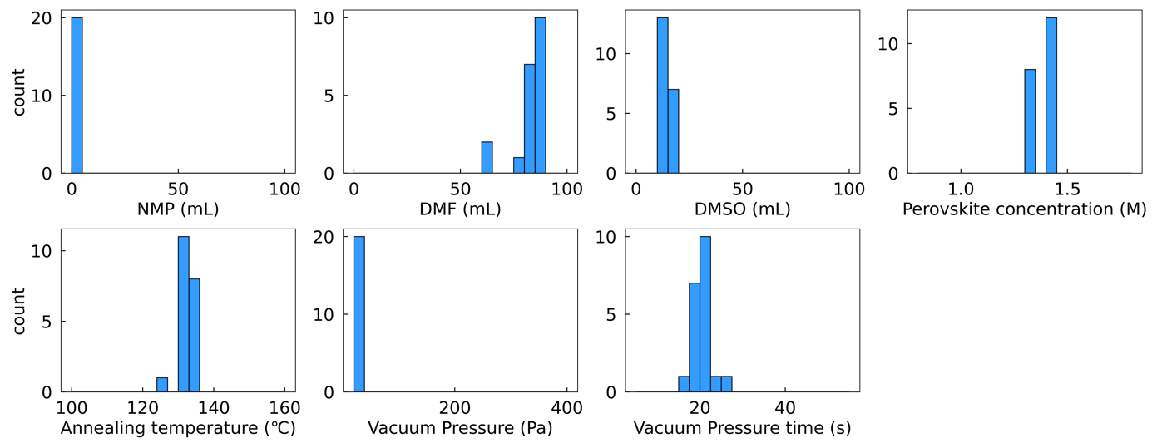
Figure 8: Bar plots visualizing the distribution of the third batch of experiments, selected by the BO algorithm, across the search space for each of the process variables.

In Figure 9, an overview of the third round of acquisition is presented. In Figure 10, the contour plots are shown. Again, the contour plots maintain the same general shape, though somewhat bigger shifts can now be observed in the plots in panel b.

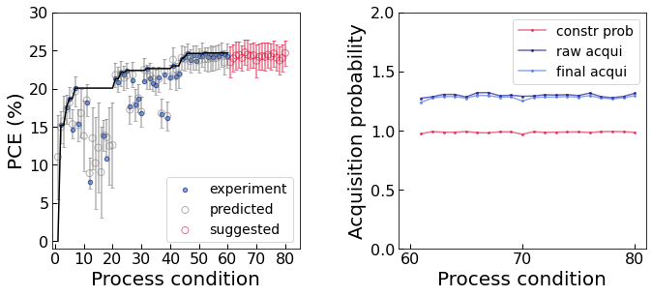
Figure 9: The acquisition process for the third sampling round. Plot of the predicted – and measured – PCE values for both the initial batch and the first selection of acquired points; the best PCE value measured so far is denoted by the bold black curve (left). Graphical summary of the acquisition probabilities across this third selection (right).

Figure 10: Sample of the 2D contour plots for the surrogate objective function: (a) DMF vs. NMP volumes, (b) Perovskite concentration vs. DMF volume. Maximum (left), mean (middle) and minimum (right) surrogate objective function values across the sample of process conditions at every grid point are visualized.

Analysis of the third batch
After the third batch, the best mean PCE value obtained his risen further to 25.1%; the best individual measurement now corresponds to a PCE of 25.3%. As could be reasonably expected, the improvements in optimal PCE values across subsequent batches have started to level off gradually, and one can assume that this trend would persist if additional samples would be taken from the search space. Given that one of our process conditions already led to a certified PCE value exceeding the current record reported in the literature, we thus decided to stop our process optimization campaign upon conclusion of this third batch. Nevertheless, opportunities for slight improvements upon the current best PCE value may still exist, particularly in the vicinity of the region on which the algorithm has zoomed in.⁶

References
- Frazier, P. I. (2018). A tutorial on Bayesian optimization. arXiv preprint arXiv:1807.02811.
- Shahriari, B., Swersky, K., Wang, Z., Adams, R. P., & De Freitas, N. (2015). Taking the human out of the loop: A review of Bayesian optimization. Proceedings of the IEEE, 104(1), 148-175.
- Genton, M. G. (2001). Classes of kernels for machine learning: a statistics perspective. Journal of machine learning research, 2, 299-312.
- Niranjan Srinivas, Andreas Krause, Sham M. Kakade, and Matthias W. Seeger (2012). Information-Theoretic Regret Bounds for Gaussian Process Optimization in the Bandit Setting. IEEE Transactions on Information Theory, 58, 3250–3265.
- Rohr, Brian, Helge S. Stein, Dan Guevarra, Yu Wang, Joel A. Haber, Muratahan Aykol, Santosh K. Suram, and John M. Gregoire (2020). Benchmarking the acceleration of materials discovery by sequential learning. Chemical Science, 11(10), 2696-2706.
- Liu, Z., Rolston, N., Flick, A. C., Colburn, T. W., Ren, Z., Dauskardt, R. H., & Buonassisi, T. (2022). Machine learning with knowledge constraints for process optimization of open-air perovskite solar cell manufacturing. Joule, 6(4), 834-849.
- Gelbart, M. A., Snoek, J., & Adams, R. P. (2014). Bayesian optimization with unknown constraints. arXiv preprint arXiv:1403.5607.
- (a) Paleyes, A., Pullin, M., Mahsereci, M., McCollum, C., Lawrence, N., & González, J. (2019). Emulation of physical processes with Emukit. In Second Workshop on Machine Learning and the Physical Sciences, NeurIPS.
- GPy: A Gaussian process framework in Python. Available at: \url{http://github.com/SheffieldML/GPy}. (since 2012).

